**CHAPTER TWO**

**2.0 LITERATURE REVIEW**

**2.1 Anatomy of the urinary bladder**

The upper urinary tract and lower urinary tract are divided into two segments for explanatory purpose (de Groat & Yoshimura, 2015). The lower urinary system is a combination of the urinary bladder and urethra, meanwhile the former is made up of the kidneys and ureters (Mahadevan, 2016).

Men have an intrapelvic bladder that only elevates above the pubis when it is pathologically dilated (Hickling *et al*., 2017). The bladder neck in a juvenile is aligned to the anterior symphysis pubis (Derrickson & Tortora, 2014). The prostate is a chestnut-sized, pyramid-shaped organ. The ejaculatory ducts, which separate the small median lobe from the center of the gland, and the prostatic portion of the urethra flow through it (Tortora & Derrickson, 2018).

The storage of urine as well as its periodic emission are the two main roles of the lower urinary tract (Jenkins & Tortora, 2016). A sophisticated neural control system in the brain and spinal cord controls these mechanisms. To maintain a reciprocal relationship between the urinary tract's reservoir (the bladder) and exit (the urethra and urethral sphincter), this control system acts as a fundamental switching circuit (Abelson *et al*., 2018).

The bladder, urethra, and prostate are all parts of the lower urinary tract in males (Scanlon & Sanders, 2018). Both the involuntary storage of urine produced in the upper urinary tract and the voluntary evacuation of urine at the proper time and location require these organs. Functional conditions like hyperactive bladder, urine incontinence, and bladder outlet obstruction brought on by enlarged prostates are frequent, as are prostate and bladder cancer (Coad *et al*., 2019).

Adapted by brandwine urology consultant

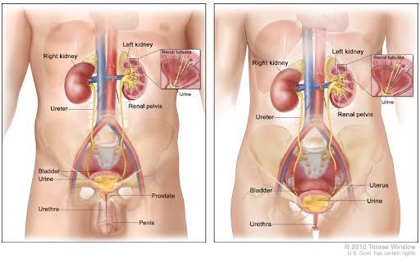Figure 2.1 **Anatomy of the urinary system**. (a) left panel showing the male urinary system with the kidneys, ureters, bladder, and urethra. (b) right panel showing the female urinary system with other organs. It shows the flow of urine from the kidneys through the ureters to the bladder. (Adapted by teresewinslow.com).

**2.1.1 Developmet of the bladder**

The primitive urogenital sinus, which is formed after the cloaca is divided, gives rise to the bladder and ureterovesical junction, which develops largely between weeks four and eight of pregnancy (Coad *et al*., 2019). The endoderm of the urogenital sinus and mesodermal mesenchyme interact with the epithelium to form the bladder (Rehman & Ahmed, 2022). The Wolffian duct and the bladder interact to create the ureterovesical junction. The Wolffian duct gives rise to the ureteric bud, which is integrated into the growing bladder at the trigone (RaJguRu *et al*., 2013). It has been demonstrated that bladder mesenchyme is where the trigonal musculature develops from most often than the Wolffian duct, contrary to earlier belief (Liaw *et al*., 2018)

f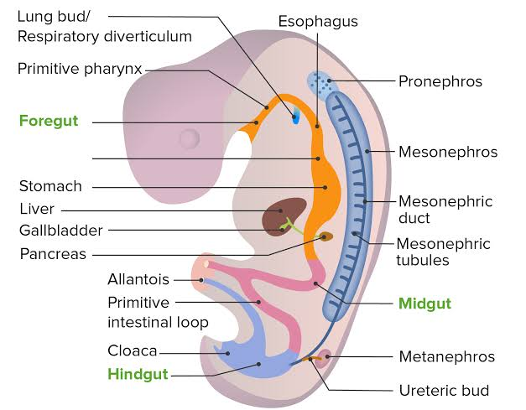

Figure 2.2 showing the developmental location of the pronephros, mesonephros, and metanephros in the developing embryo during the development of bladder (image by lecturio *et al.,* 2013).

**2.1.2 Musculature of the bladder**

At the bladder neck, there are two muscles that act as sphincters: one is voluntary, the other is involuntary, and they are spaced at least an inch apart (Miyazato *et al*., 2013). The development of the ejaculatory ducts in between them explains the existence of this dual musculature (Breshears & Confer, 2017). When semen is released, if both of these muscles are open, secretion may escape into the bladder or to the outside, and any urine in the bladder would also flow out (Rehfeld *et al*., 2017). During ejaculation, the internal sphincter normally relaxes strongly (Kızılkaya Beji *et al*., 2020).

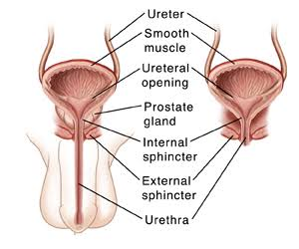

Figure 2.3 showing the outer layer of muscle surrouding the urinary bladder. (Adapted by (Saint lukes *et al*., 2013)

**2.1.3 Neurovasculature of the bladder**

With its thoracodorsal nerve coaptated to the lowest branch of the intercostal nerve, the latissimus dorsi muscle (LDM) is partially wrapped around the acontractile bladder (Benz *et al*., 2018). Following the reinnervation of the LDM, rectus abdominis and transplanted latissimus muscles activate simultaneously, causing the bladder to be voluntarily emptied (Pan *et al*., 2013). The nerve coaptation promotes a synergistic function of both muscles since the contraction of both muscles increases the intravesicular pressure (Ninkovic *et al*., 2012)

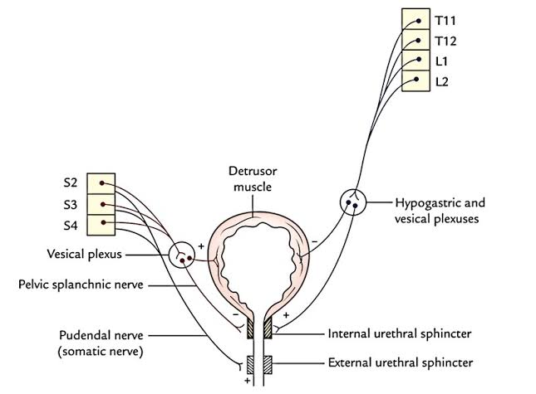 Figure 2.4 Urinary bladder nerve supply (Adapted by earthslab.com)

**2.1.4 Epithelial lining of the bladder**

The lower urinary tract's primary function is to temporarily store and then occasionally remove urine from the bladder (Garg, 2015). For this, a sophisticated brain control system must coordinate the striated muscles of the pelvic floor and outflow region with the smooth muscles of the bladder and urethra (Bolla *et al*., 2022). Afferents in the hypogastric and pudendal nerves, as well as lumbosacral afferent fibers (pelvic afferents), are crucial for controlling the mechanisms for continence and micturition (J. Wang & Manucha, 2016). Afferent nerves have been found in the detrusor muscle and suburothelially in the bladder. They create a plexus suburothelially that is located directly below the epithelial lining (Friedell *et al*., 2017). The trigone and bladder neck have unusually dense areas of this plexus (Liaw *et al*., 2018). Myelinated A-fibers and unmyelinated C-fibers are the two main afferents in the micturition process (Souza *et al*., 2018).

Numerous peptides, including substance P, calcitonin gene-related peptide, vasoactive intestinal polypeptide, enkephalins, and cholecystokinin, are localized either alone or in combination in afferent pathways of the bladder and urethra, according to immunocytochemical and tracing investigations (Samaratunga *et al*., 2013).

These nerves contain vanilloid, purino, tachykinin, and prostanoid receptors among others (Nakagomi *et al*., 2016). It has been discovered that extracellular adenosine triphosphate (ATP) mediates the activation of small-diameter sensory neurons via P2X3 receptors (Takezawa *et al*., 2017). It has also been hypothesized that bladder distention triggers the release of ATP from the urothelium (Takezawa *et al*., 2017). In turn, ATP can trigger a neuronal discharge by activating P2X3 receptors on suburothelial afferent nerve terminals (Guan *et al*., 2018). However, it is most likely that ATP is also a part of the transduction mechanisms underpinning the activation of afferent fibers during bladder filling, in addition to a cascade of inhibitory and stimulatory transmitters/mediators (Andersson, 2015).

ff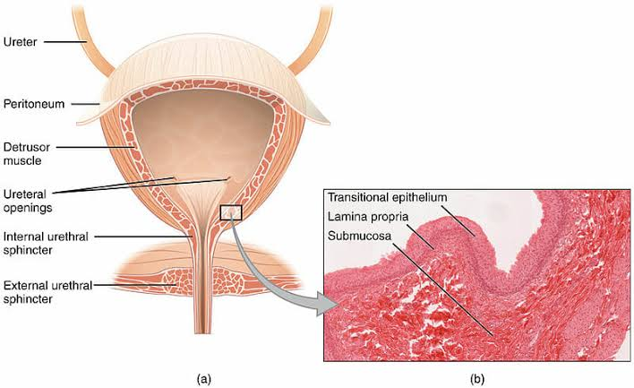

Figure 2.5 **a cross section of the bladder showing inset histology of the epithelium**. (a) Showing the musculation of the bladder (b) Displaying the epithelium, connective tissue and submucosa.

**2.2 Bladder cancer**

For both men and women, bladder cancer ranks as the 10th most prevalent type of cancer. Bladder cancer can range from noninvasive, mostly nonaggressive tumors that return and subject patients to long-term invasive surveillance to invasive, highly lethal tumors (Lenis *et al*., 2020) Bladder cancer is primarily caused by cigarette smoking, advanced age, and male sex (Kamat *et al*., 2016). Depending on the degree of hematuria and risk of malignancy, bladder tumors can appear with either gross or microscopic hematuria, which is assessed using cystoscopy and upper tract imaging (Antoni *et al*., 2017). Depending on the risk level, endoscopic resection and adjuvant intravenous therapy are used to treat non-muscle-invasive cancers (Lenis *et al*., 2020).

If not properly treated, bladder cancer is a difficult condition with significant rates of morbidity and fatality (Nadal & Bellmunt, 2019). The key to a successful outcome is early identification, individualized treatment, and follow-up. Haematuria should be recognized as the primary presenting symptom (Kamat *et al*., 2016). Painless haematuria is the primary presenting symptom of all bladder malignancies, and urine cytology and transurethral tumour removal are used to confirm the diagnosis (Zhu *et al*., 2019). Carcinomas in situ and other high grade, non-muscle-invasive tumors are treated intravenously (Mushtaq *et al*., 2019). In some circumstances, bladder preservation with transurethral tumour excision, radiation therapy, and chemotherapy can be equally effective (Kluth *et al*., 2015). Numerous chemotherapeutic drugs have demonstrated efficacy in patients with metastatic illness and as neoadjuvant or adjuvant therapy (Richters *et al*., 2020).

The main risk factors for bladder cancer are exposure to carcinogens at work or in the environment, particularly tobacco (Barani *et al*., 2021). Patients with macroscopic haematuria are typically the first to be identified with bladder cancer, and cases are confirmed via transurethral resection of bladder tumors (TURBT), which also acts as the initial stage of therapy (Sanli *et al*., 2017). The methods for diagnosing and treating localized and advanced disease have changed as a result of advances in our understanding of the molecular biology and genetics of bladder cancer. The standard of care for intermediate- and high-risk non-muscle-invasive bladder cancer remains intravesical BCG, but the range of treatment options for muscle-invasive and advanced disease has increased to include immunotherapy with checkpoint inhibition, targeted therapies, and antibody-drug conjugates (Yeung *et al*., 2014).

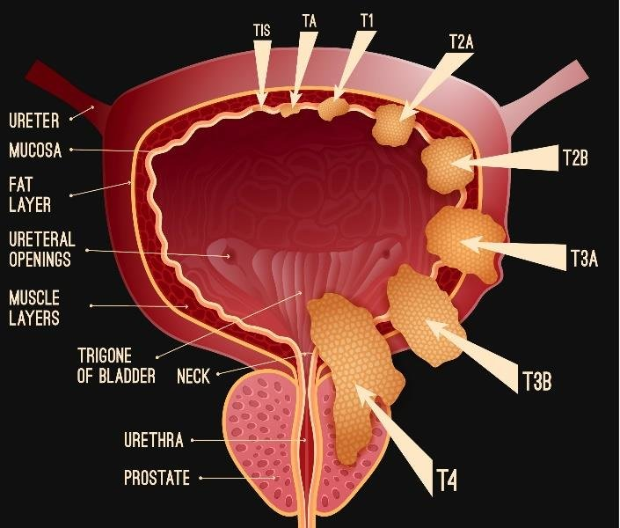

Figure 2.6 **Demonstration of several bladder cancer pathogenic stages.** TIS stage: showing the flat cancerous cell inside the cell lining of the bladder; TA stage: specifically in the lining cell; T1 stage: initial inner membrane of the bladder; T2A stage: inside bladder muscle; T2B stage: deep into bladder muscle; T3A stage: into bladder fat; T4 stage: various organs around the bladder are infected (cervix, vagina, prostate) (Kurilchik et al., 2020).

**2.2.1 Classification of bladder cancer**

A variety of malignancies, including those that are (1) papillary in nature and restricted to the mucosa, (2) high grade and flat and restricted to the epithelium, and (3) invasive into the submucosa, or lamina propria, make up the category of superficial "non-muscle-invasive" bladder tumors (Chou *et al*., 2016).

**2.2.1.1 Muscular invasive**

Muscle-invasive bladder cancer (MIBC) has a wide range of molecular variations and a variety of clinical manifestations (Kamoun *et al*., 2020). Various tumors with different biologic potential make up the large category of nonmuscle invasive bladder cancers (Patel *et al*., 2020). The precise integration of diagnostic and surveillance tests, macroablation via transurethral resection, accurate diagnosis of the clinical stage, and the timely and appropriate administration of intravesical chemotherapeutic and immunomodulatory agents are all essential components of a successful treatment plan (Sexton *et al*., 2010).

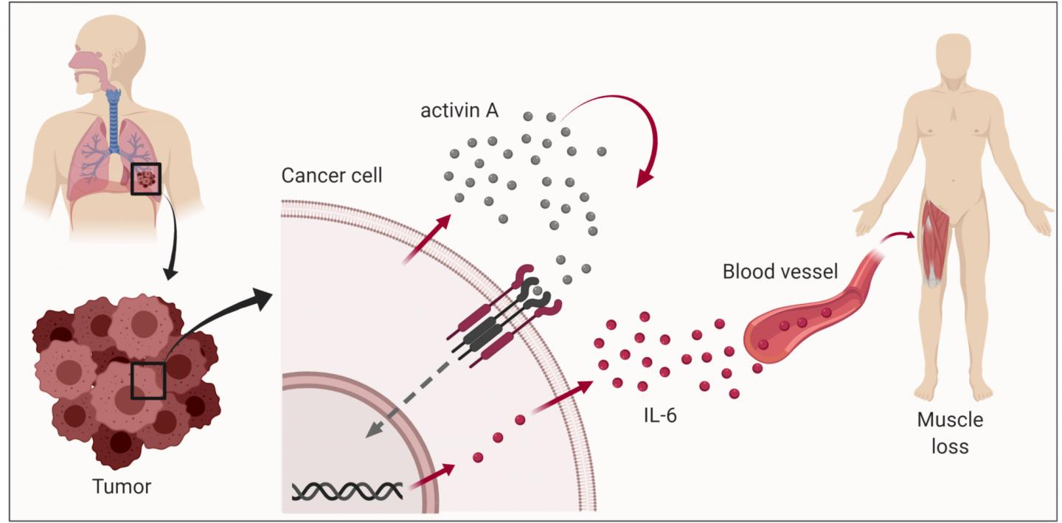

Figure 2.7 **Showing Activin A and IL-6 are both key signalling factors and functionally linked.** Demonstrating how cancer cell break your muscle. (Adapted by biorender.com)

**2.2.1.2 Non Muscular invasive**

The majority of bladder cancer diagnoses are for non-muscle-invasive bladder cancer (NMIBC) (Tan *et al*., 2016), yet this term encompasses a spectrum of diseases with varying clinical outcomes, notable for high risk of progression and recurrence (Chang *et al*., 2016). In order to preserve the bladder when it is safe to do so, management involves risk-adapted methods of cystoscopic surveillance and intravesical therapy (Woldu *et al*., 2017).

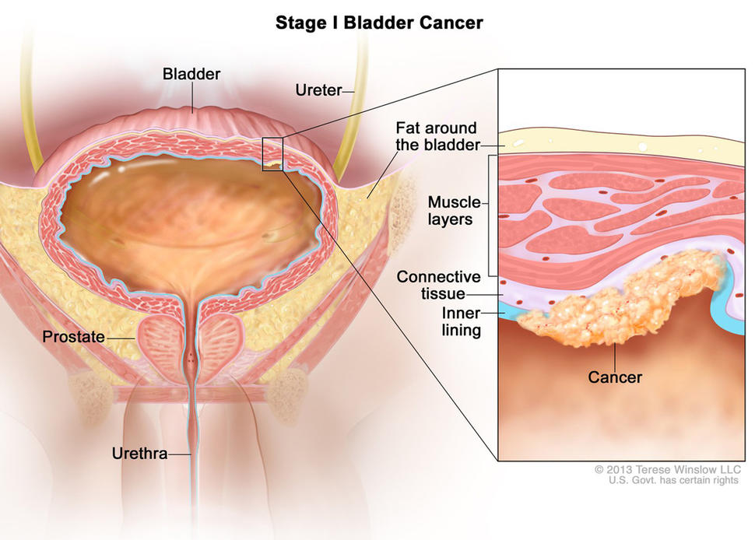

Figure 2.8 **The bladder's muscle layers have not been penetrated by low-grade, or stage I, bladder cancer.** Showing the non- muscle cancer. (Adapted by national cancer institute)

**2.2.2 Types of bladder cancer.**

**2.2.2.1 Urothelial carcinoma**

The 4th most frequent cancer in males and the 8th most frequent cause of cancer-related death in men in the United States is bladder urothelial carcinoma (A. *et al*., 2013). A rare subset of urothelial malignancies with a bad prognosis is upper tract urothelial carcinoma (Miyazaki & Nishiyama, 2017). The male to female ratio for upper tract urothelial carcinoma is 2:1, with men being more likely to develop cancer than women (Hedegaard *et al*., 2016). The primary risk factors for upper tract urothelial carcinoma and urinary bladder cancer are cigarette smoking and occupational exposure, whereas other factors are more unique to the carcinogenesis of upper tract urothelial carcinoma (Sfakianos *et al*., 2015).

**2.2.2.2 Squamous cell carcinoma**

As far as non-melanoma skin cancers go, squamous cell carcinoma (SCC) is the second most prevalent (Kallini *et al*., 2015). It comes from adnexal structures or epidermal keratinocytes (such as eccrine glands or pilosebaceous units) (Kallini *et al*., 2015).

**2.2.2.3 Adenocarcinoma**

Adenocarcinoma is a rare type of bladder cancer that can develop primarily in the bladder or in other organs as a secondary cause (Dadhania *et al*., 2015). The growth patterns of primary bladder adenocarcinomas can be enteric, mucinous, signet-ring cell, not otherwise characterized, or mixed (Kuhn *et al*., 2018). Secondary adenocarcinomas of the bladder are more common than primary adenocarcinomas and can be either primary or secondary. Although primary bladder adenocarcinoma originates from the bladder urothelium, it exhibits a strictly glandular character histologically (Humphrey *et al*., 2016). Secondary adenocarcinomas can spread to the bladder directly or by metastasis from another location. Secondary bladder adenocarcinomas frequently develop from the colon, prostate, endometrial, cervix, breast, and lung (Santos *et al*., 2015).

**2.2.2.4 Transitional cell carcinoma**

The most prevalent cancer of the urinary tract in mens is transitional cell carcinoma (TCC) of the bladder, which is difficult to diagnose and efficiently treat (Kamat *et al*., 2016). This disease may be becoming more common (DeGeorge *et al*., 2017). Chemotherapy can not effectively treat this tumor and it is tough to remove surgically (Griffiths & Cancer, 2013). Further research is required to determine whether radiation and other treatment techniques are effective.

**2.2.2.5 Small cell carcinoma of the bladder**

Small cell bladder cancer (SCCB) is an uncommon condition with significant invasiveness and fatality rates. SCCB and small cell lung cancer (SCLC) are difficult to identify histologically; However, it has molecular changes that are more similar to urothelial cancer (UC) (Y. Wang *et al*., 2019). Although small-cell carcinoma of the urinary bladder is a very uncommon pathology, it has a negative prognosis and an aggressive behavior (Ghervan *et al*., 2017).

These tumors occasionally respond less well to adjuvant (chemo)therapy because they have pure squamous cell or glandular differentiation (Todenhöfer & Seiler, 2019). Small cell bladder cancer exhibits an aggressive course and mirrors the neuroendocrine characteristics of its pulmonary counterpart, but is susceptible to (neo-)adjuvant treatment (Bertz *et al*., 2016).

**2.2.3 Epidemiology of bladder cancer**

According to the most recent GLOBOCAN data, 3% of cancer diagnoses worldwide are for bladder cancer, which is more common in industrialized countries (Saginala *et al*., 2020). Bladder cancer is the sixth most common tumor in the United States (Malats & Real, 2015). 90% of bladder cancer diagnoses occur in patients 55 years of age and older, and men are four times more likely than women to develop the disease (Cumberbatch *et al*., 2018) . While the 5-year survival rate in the US is 77% on average, it is only a pitiful 5% for people who have metastatic disease (Christoforidou *et al*., 2013). Smoking, which causes 50–65% of cases, is the biggest risk factor for bladder cancer (Hrudey *et al*., 2015). While bladder cancer develops decades after exposure, even if the exposure only lasted a few years, the precise fraction can be disguised (Mossanen, 2021). Occupational or environmental toxins can significantly contribute to disease burden, accounting for an estimated 20% of all cases (Abdollah *et al*., 2013).

In countries of Africa and the Middle East, schistosomiasis infection is a common cause of bladder cancer and is regarded as the second most dangerous tropical pathogen after malaria (Chavan *et al*., 2014). Bladder cancer is an excellent candidate for preventative measures, with 81% of cases related to recognized risk factors (and only 7% to heritable mutations) (Barrow & Michels, 2014). It has been proven that quitting smoking, adopting workplace safety procedures, losing weight, exercising, and preventing schistosomiasis (by water disinfection and mass medicine administration) all greatly lower the incidence of bladder cancer, which is a growing global burden (Saginala *et al*., 2020).

**2.2.4 Prevalence of bladder cancer in Nigeria**

Bladder cancer (BC), the tenth most prevalent malignancy worldwide, accounts for 3% of all new cancer cases and 2% of all cancer fatalities (Iya *et al*., 2022). The prevalence is increasing throughout Africa, with North Africa recording the highest rates (Sule *et al*., 2017). According to statistics, there are 10.1 and 5.0 men and 2.0 and 1.5 females per 100,000 in Africa, respectively (Abdulkadir *et al*., 2016). Nigerian BC is ranked seventh overall, second among men and eleventh among women (Ofuru *et al*., 2017). Non-muscle-invasive (NMIBC) and muscle-invasive (MIBC) stage groupings are recognized descriptions of BC in industrialized countries. Countries, with the former category accounting for 75%–80% of new cases and the latter for 20%–25% (Iya *et al*., 2022).

Urothelial carcinoma or transitional cell carcinoma (TCC), which accounts for around 90% of all BC cases in developed nations, is the most common histological subtype of BC (Forae *et al*., 2016). Smoking and exposure to chemicals used in the dye industry are risk factors for transitional cell carcinoma (TCC) (AO *et al*., 2013). It has a fair prognosis since it typically manifests at an early stage without detrusor muscle involvement (NMIBC) (Ossai *et al*., 2014). However, the most prevalent variety of non-urothelial carcinoma, squamous cell carcinoma (SCC), is more prevalent in low- and middle-income nations, including those in the Middle East and several regions of Africa, like nigeria, ghana etc, is frequently more common than TCC (Ogefere *et al*., 2021).

Schistosomiasis (Bilharzia)-associated and non-schistosomiasis-associated SCC are the two main subtypes of SCC, yet it's crucial to remember that they don't differ morphologically (Singh *et al*., 2016). Schistosomiasis-associated SCC is particularly prevalent in the Middle East and some regions of Africa, like Nigeria where Schistosoma haematobium infection is predominant (Onile *et al*., 2016). When compared to TCC, SCC is a more aggressive condition with a worse prognosis (Adeboye *et al*., 2021). SCC is the most prevalent subtype of SCC in Northern Nigeria (Kiran & D, 2014) .

Despite the reduced prevalence of schistosomiasis in Northern Nigeria, bladder cancer (BC) represented 53% of cases (Ojo *et al*., 2021). Meanwhile, it has been noted that schistosomiasis was more common in Southern Nigeria than the North, with an estimated 20% of BCs there being SCC (Otuneme *et al*., 2015).

This emphasizes the potential significance of undiscovered environmental and/or genetic factors in mediating the discrepancy in histologic type between the northern and southern regions of the nation (Forae *et al*., 2016). This scoping review aims to identify gaps in clinical care and research on BC in Nigeria due to the dearth of published material pertaining to the epidemiology, clinical therapy, and translational research into BC in Nigeria.

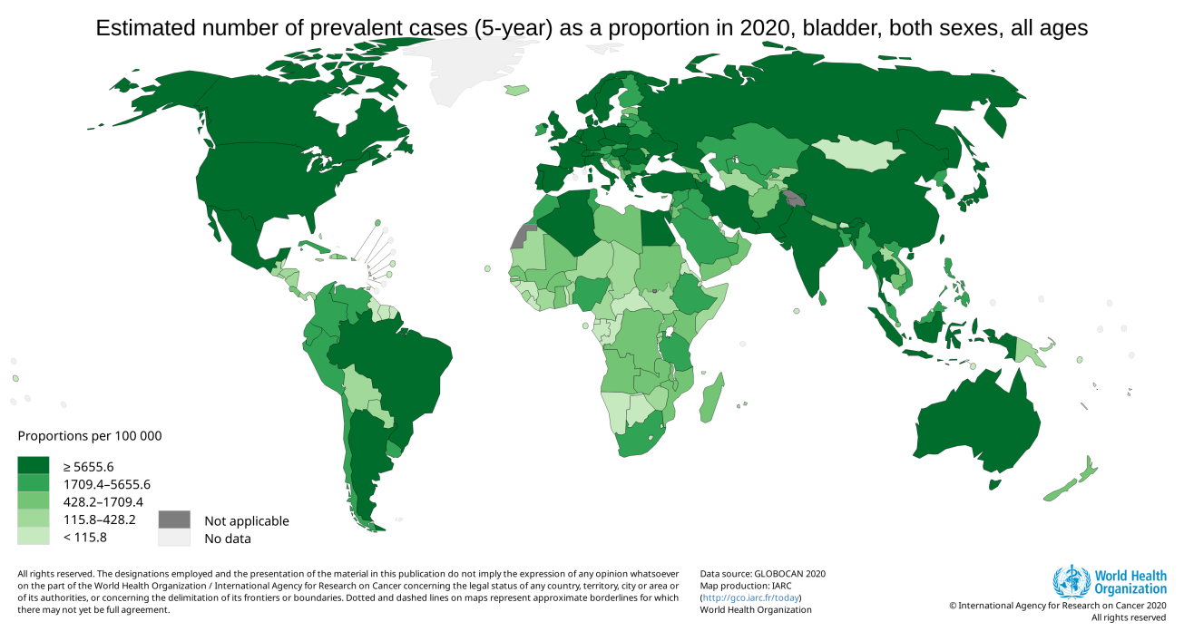 Figure 2.9 Graphical map showing the estimated number of prevalent cases of bladder cancer by both sexes and ages. (Adapted by GLOBOCAN)

**2.2.5 Risks factors of bladder cancer**

In developed nations, cigarette smoking is known to be the primary cause of bladder cancer, accounting for roughly 50% of cases (Al-Zalabani *et al*., 2016). There is a significant correlation between the quantity and frequency of cigarette smoking (Letašiová *et al*., 2012). Working with some aromatic amines has been linked to a greater incidence of bladder cancer (Burger *et al*., 2013). According to estimates based on these and other occupational risks, 5–10% of bladder cancer cases in industrialized nations were brought on by exposures related to the workplace (Lenis *et al*., 2020). In regions of the world where Schistosoma haematobium infestation is endemic, infectious agents have a significant impact on the risks of bladder cancer (Chavan *et al*., 2014). Other urinary tract (UT) infections and drinking tap water contaminated with arsenic or chlorination byproducts are further potential risk factors for bladder cancer (Mahdavifar *et al*., 2016). It has been demonstrated that exposure to several medications, such as the chemotherapy agent cyclophosphamide and heavy phenacetin-containing painkiller use, can result in bladder cancer in people (Chang *et al*., 2016). High fruit and vegetable and total fluid intake are likely linked to a little reduction in risk (Farling, 2017).

For the prevention of bladder cancer, it should be advised to avoid tobacco use, questionable occupational exposures, a regular diet rich in fresh fruits and vegetables, as well as the prevention and treatment of urinary tract infections (Patel *et al*., 2020).

**2.2.6 Management of bladder cancer**

The kind, grade, and stage of the cancer, as well as your general health and management preferences, are taken into consideration when determining the best course of treatment for bladder cancer. Bladder cancer can be managing through the following procedures;

**2.2.6.1 Surgery**

To remove the cancer cell, which include following strategies?

* **Transuretheral resection of bladder tumor (TURBT);** is a procedure used to identify bladder cancer and remove tumors that are only found in the inner layers of the bladder and have not yet spread to the muscles (Cheung *et al*., 2013).
* **Cystectomy;** is a surgical procedure that removes all or some of the bladder. Your doctor simply removes the section of the bladder that has a single malignant tumor during a partial cystectomy (Parekh *et al*., 2018).
* **Neobladder reconstruction;** Your surgeon will need to design a new pathway for urine to leave your body following a radical cystectomy (urinary diversion) (Minervini *et al*., 2014). Neobladder reconstruction is one method for urine diversion (Crozier *et al*., 2016). A section of your intestine is formed into a sphere by your surgeon. This internal reservoir, sometimes known as a neobladder, is connected to your urethra. Most people can urinate properly due to the neobladder (Hrbáček *et al*., 2015).
* **Ileal coduit;** Your surgeon uses a section of your intestine to construct a tube (ileal conduit) to perform this type of urine diversion. The tube exits your body through your ureters, which drain your kidneys, and empties into a pouch (urostomy bag) that you wear on your belly (Minervini *et al*., 2014).
* **Continent urinary reservoir**; in this kind of urinary diversion surgery, your surgeon creates a tiny pouch (reservoir) within your body to store urine using a segment of intestine (Kapoor, 2021).

**2.2.6.2 Chemotherapy**

Drugs are used in chemotherapy to kill cancer cells. Typically, two or more chemotherapy medicines are used in combination to treat bladder cancer (Chou *et al*., 2016).

**2.2.6.3 Radiation therapy**

Protons and other high-energy beams, such as X-rays, are used in radiation therapy to kill cancer cells (Turgeon *et al*., 2014). Typically, a machine that moves about your body delivers radiation therapy for bladder cancer by aiming energy beams at specific locations (Yang *et al*., 2017). When surgery is not an option or is not wanted, radiation treatment may be used in conjunction with chemotherapy to treat bladder cancer (Griffiths & Cancer, 2013).

**2.2.6.4 Immunotherapy**

A medicinal therapy called immunotherapy supports your immune system's ability to fight cancer (Kamat *et al*., 2016).

**2.2.6.5 Targeted therapy**

Drugs used in targeted therapy concentrate on particular flaws in cancer cells (Knollman *et al*., 2015). Targeted medication therapies can kill cancer cells by focusing on these vulnerabilities (Spiess *et al*., 2017). To determine whether targeted therapy is likely to be successful, your cancer cells may be examined.

**2.3 Prognostic and Diagnostic biomarkers**

Due to the nature of this malignancy, lifetime monitoring is necessary. As a result, of all cancers, bladder cancer has the most expensive total cost through diagnosis to death (Ghafouri-Fard *et al*., 2014b). This emphasizes the requirement for a suitable cancer marker for surveillance of patients with a history of bladder cancer as well as screening of high risk individuals (Ye *et al*., 2014). Urinary indicators appear to be promising diagnostic tools and bladder cancer follow-up. Until now, a number of molecular tests in this area have been sold commercially (Jayanthi *et al*., 2017). Some of them are currently in use, while others are still being tested. Molecular testing is typically compared to voided urine cytology (VUC), the gold standard for the identification of bladder cancer (Goossens *et al*., 2015). DNA, RNA, miRNA, and protein markers are the different types of molecular markers (Chou *et al*., 2015). There are just a few authorized markers, including immunocytochemistry, bladder tumor antigen (BTA), nuclear matrix protein (NMP22), and fluorescence in-situ hybridization (FISH), Stat, and Trak. for use in primary screening of high-risk individuals for bladder cancer and/or bladder cancer monitoring by the US Food and Drug Administration (FDA) (Frantzi *et al*., 2015).

**2.3.1 Types of biomarkers**

**2.3.1.1 DNA markers**

Different stages of bladder cancer have been discovered to be correlated with complex chromosomal alterations as well as specific mutations (Dudley *et al*., 2019). For example, chromosome 9 deletion is a very unique alteration that is frequently observed in Ta/T1 and less frequently in muscle invasive bladder tumors (MIBC) (Kandimalla *et al*., 2013). Chromosome 9 deletions have been thought to be an early event in the course of bladder cancer since it is frequently identified as the only aberration (Mouw, 2017).

* **UroVysion:** The goal of this test is to identify aneuploidy of chromosomes 3, 7, and 17 as well as the deletion of the chromosomal 9p21 region in urine samples using FISH. It is one of the few indicators to have seen widespread clinical application. Additionally, it is useful for keeping track of individuals with superficial bladder cancer (Lopez-Beltran *et al*., 2020).
* **Epigenetic changes:** Observable epigenetic alterations Gene expression is significantly influenced by DNA methylation (Kandimalla *et al*., 2013). Recent research has shown that abnormal DNA methylation occurs frequently and early in the development of human cancer (Ng *et al*., 2021). It has been demonstrated that the same promoter regions and a significant amount of it occur in cancer cells. Promoter methylation appears to be a useful biomarker for bladder cancer early diagnosis (Leiblich, 2017).
* **Point mutation:** The mutation assays are diagnostic methods for determining whether patients will respond well to targeted treatments. They are promising biomarkers for finding recurrences while monitoring patients (Knowles & Hurst, 2015).

**2.3.1.2 RNA markers**

* **Expression of telomerase in urine:** It has been demonstrated that the level of telomerase activity in urine is a reliable indicator of bladder cancers (Ghafouri-Fard *et al*., 2014a).
* **Expression of survivin in urine:** It belongs to the class of proteins called inhibitors of apoptosis (Liang *et al*., 2018). The marker had an excellent negative predictive value and specificity but a poor positive predictive value and sensitivity in a significant prospective investigation on survivin performance for bladder cancer screening (Gogalic *et al*., 2015).

**2.3.1.3 Proteins markers**

* **Alpha-defensin:** Itis known that it may serve as a urine marker for bladder cancer (Darwiche *et al*., 2015). Additionally, it has been demonstrated that bladder cancer cells frequently express alphadefensin peptides (Suarez-Carmona *et al*., 2015). Therefore, it has been proposed that autocrine tumor production of alpha defensins may have a significant impact on patients' bladder cancer's invasiveness (Maneerat *et al*., 2016).
* **Cytokeratins:** The intracytoplasmic cytoskeleton of epithelial tissue contains intermediate filaments called cytokeratins, which contain keratin (Poli *et al*., 2015). The use of these tests for bladder tumor surveillance has been constrained by their high risk of false positive results and inability to identify low-grade cancers (D’Costa *et al*., 2016).

In order to reduce the need for cystoscopy for patient diagnosis or surveillance, cancer researchers are now looking for biomarkers for bladder cancer. Markers can be utilized for treatment decision making in addition to cancer detection.